24.46: a) The capacitance changes by a factor of K when the dielectric is inserted. Since V is unchanged (The battery is still connected),
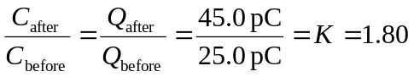
b) The area of the plates is and the separation between them is thus
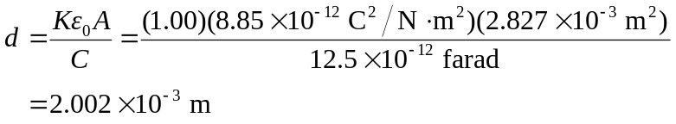
Before the dielectric is inserted,
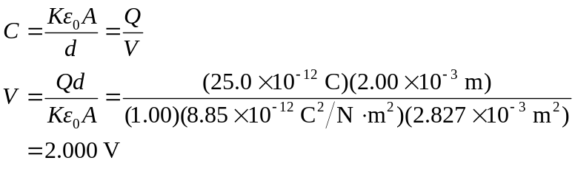
The battery remains connected, so the potential difference is unchanged after the dielectric is inserted.
c) Before the dielectric is inserted,
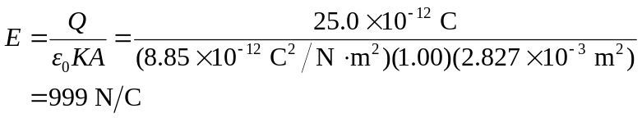
Again, since the voltage is unchanged after the dielectric is inserted, the electric field is also unchanged.

